**Register User**

POST {{endpoint}}/api/register

|  |  |  |
| --- | --- | --- |
| **Request Field** | **Field Type** | **Field Description** |
| name | String | The user’s full name |
| password | String | The user’s password |
| passwordConfirmation | String | Confirmation of the password above. They must match. “123456” is placed for convenience, but the passwords are salted and hashed using BCrypt. This can be seen via the DB. |
| email | String | The user’s email |
| highScore | Number | The user’s high score |

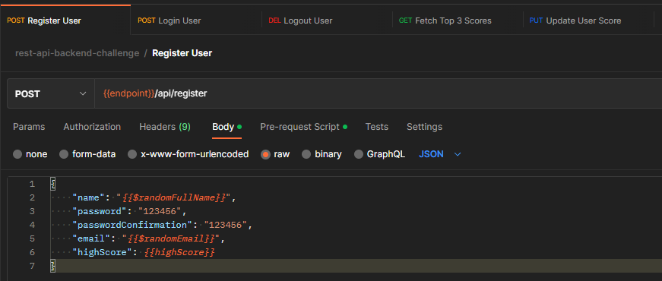

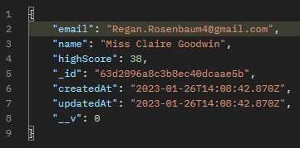

**Login User**

POST {{endpoint}}/api/login

|  |  |  |
| --- | --- | --- |
| **Request Field** | **Field Type** | **Field Description** |
| email | String | The user’s email |
| password | String | The user’s password |

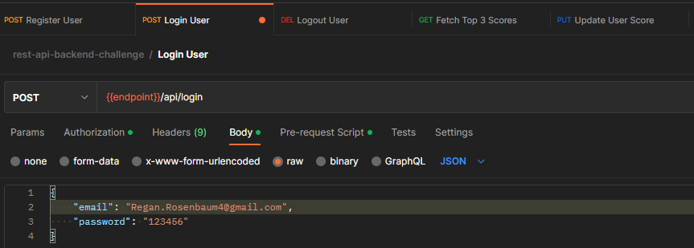

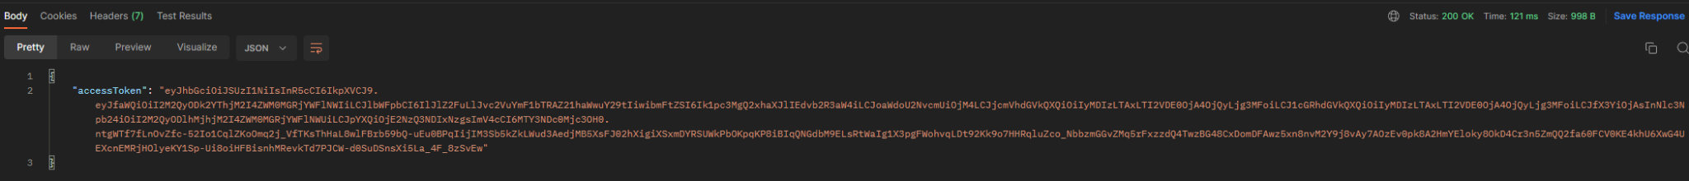

**Logout User**

DEL {{endpoint}}/api/logout

|  |  |  |
| --- | --- | --- |
| **Request Field** | **Field Type** | **Field Description** |
| email | String | The user’s email |
| password | String | The user’s password |

Access token placed for the request:

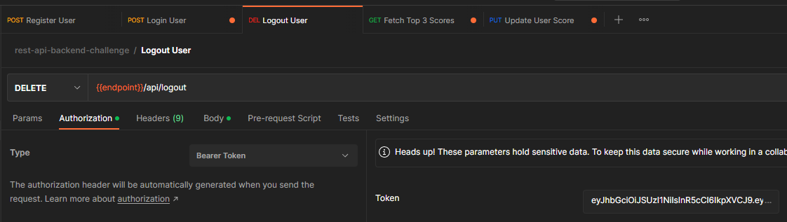

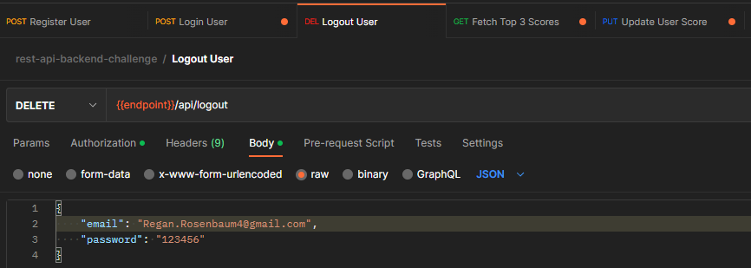

Access token revoked upon logging out:

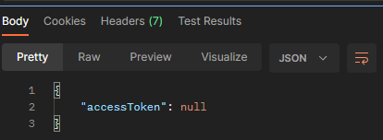

**Fetch Top 3 Scores**

GET {{endpoint}}/api/leaderboard/fetch

|  |  |  |
| --- | --- | --- |
| **Request Field** | **Field Type** | **Field Description** |
| - | - | - |

Access token placed for the request:

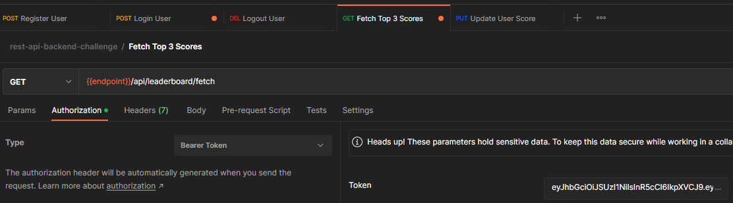

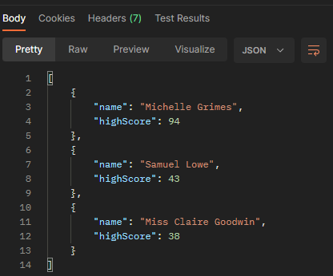

**Update User Score**

PUT {{endpoint}}/api/leaderboard/update

|  |  |  |
| --- | --- | --- |
| **Request Field** | **Field Type** | **Field Description** |
| _id | String | Generated object id for the user when they registered |
| newHighScore | Number | Any positive integer to replace the user’s current score. Only scores above the user’s current score will be retained |

Access token placed for the request:

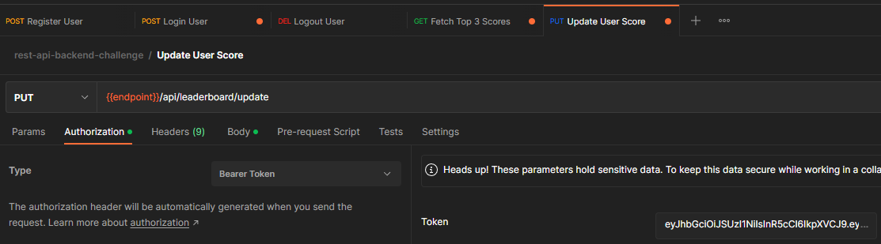

Object id for the user:

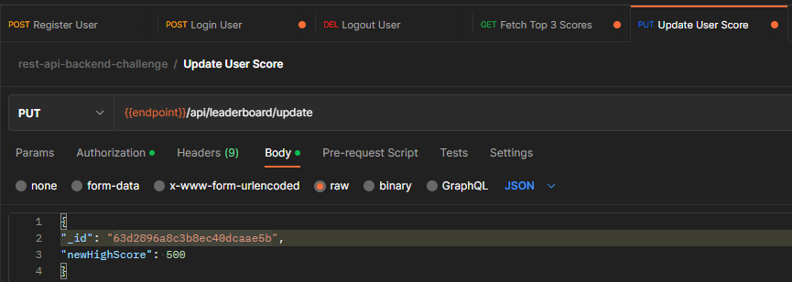

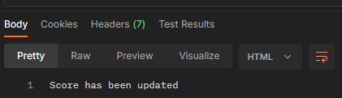

Attempting a lower score now:

